**Description**

As a user I must have ability to view Home page contents.

As a user I should have ability to navigate to menu , Contact info and Store info .

------------------------------------------------------------------------------------------------------------------------------------------

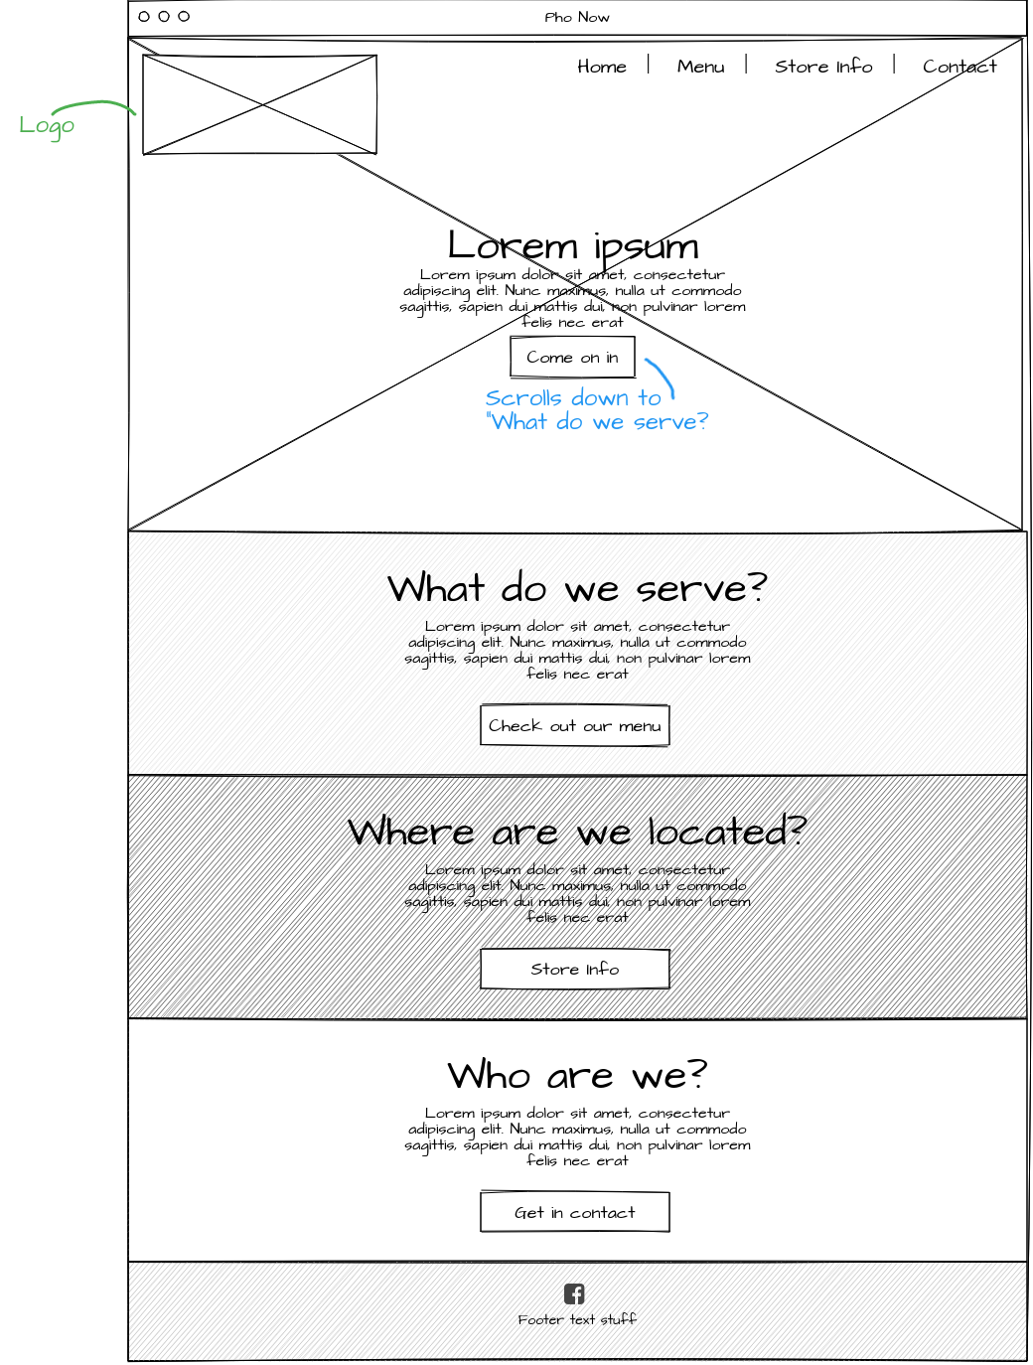

**Acceptance criteria**

* Display restaurant logo.
* Display brief description about “what do we serve”
* Display brief description about “where are we located”
* Display brief description about “Who are we”